Environment:

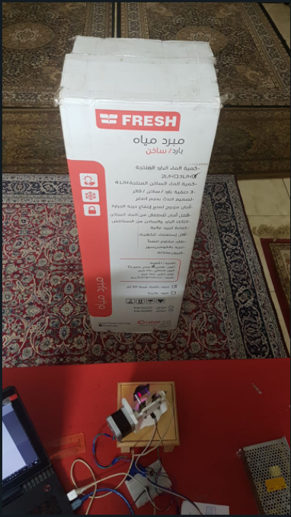

Distance between radar and object = 51 cm, Bin resolution = 4, Entering point = step number 27 12.15 degree, Exit point = step number 109 49.05 degree, Without CFAR, Total angel = 67.5 with step size = 1, Total number of steps = 150 step each step = 0.45 degree

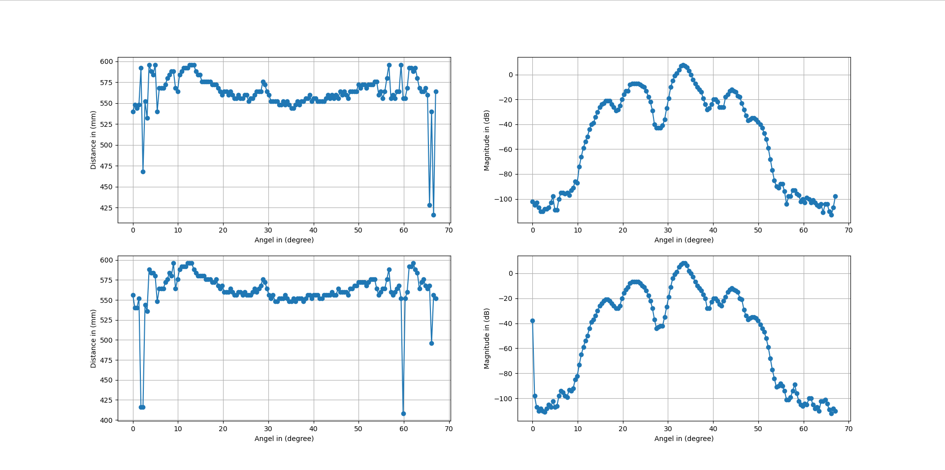

Row number # 1

[-102, -105, -103, -107, -110, -110, -108, -108, -107, -103, -98, -109, -109, -100, -95, -95, -96, -95, -97, -93, -91, -86, -87, -74, -66, -59, -54, -50, -44, -40, -39, -34, -30, -26, -24, -23, -21, -21, -21, -24, -26, -29, -28, -25, -20, -16, -13, -13, -8, -7, -7, -7, -7, -8, -9, -10, -13, -18, -22, -29, -40, -43, -43, -43, -41, -36, -27, -19, -10, -5, -1, 1, 4, 7, 8, 7, 6, 3, 0, -4, -7, -10, -12, -14, -19, -24, -28, -27, -24, -20, -20, -22, -26, -26, -26, -18, -16, -13, -12, -13, -14, -17, -18, -23, -28, -33, -37, -36, -35, -35, -36, -38, -40, -43, -47, -52, -59, -68, -77, -85, -90, -91, -88, -88, -94, -104, -98, -98, -93, -93, -96, -97, -102, -100, -103, -99, -100, -103, -101, -103, -105, -106, -104, -111, -104, -104, -110, -113, -107, -98]

[540, 548, 544, 548, 592, 468, 552, 532, 596, 588, 584, 596, 540, 568, 568, 568, 572, 580, 584, 588, 588, 568, 564, 584, 588, 592, 592, 592, 596, 596, 596, 588, 584, 584, 576, 576, 576, 576, 576, 572, 572, 572, 568, 564, 560, 564, 564, 560, 564, 560, 556, 556, 560, 556, 556, 560, 560, 552, 556, 556, 560, 564, 564, 564, 576, 572, 564, 560, 552, 552, 552, 552, 548, 548, 552, 548, 552, 548, 544, 544, 548, 552, 548, 552, 552, 556, 556, 560, 552, 556, 556, 552, 552, 552, 552, 556, 560, 556, 560, 556, 560, 556, 564, 560, 564, 560, 556, 564, 564, 564, 564, 572, 568, 572, 572, 568, 572, 572, 572, 576, 576, 560, 564, 556, 564, 580, 596, 556, 560, 556, 564, 564, 596, 556, 556, 568, 592, 592, 588, 592, 580, 568, 564, 564, 568, 560, 428, 540, 416, 564]

Row number # 2

[-38, -98, -107, -110, -108, -110, -111, -108, -105, -107, -102, -107, -106, -98, -94, -95, -98, -99, -93, -94, -92, -85, -82, -73, -65, -59, -54, -50, -44, -39, -37, -34, -30, -26, -24, -22, -21, -21, -22, -24, -26, -28, -28, -26, -20, -16, -13, -11, -8, -7, -7, -7, -7, -8, -10, -11, -14, -18, -22, -28, -37, -44, -43, -42, -42, -35, -27, -19, -11, -4, -1, 1, 5, 7, 8, 8, 6, 2, 0, -3, -7, -10, -12, -14, -17, -20, -28, -28, -23, -20, -20, -22, -25, -26, -22, -19, -15, -13, -12, -13, -14, -15, -20, -21, -29, -34, -37, -36, -35, -35, -36, -38, -41, -44, -47, -52, -59, -68, -77, -84, -91, -90, -88, -90, -94, -101, -101, -99, -94, -89, -96, -102, -105, -106, -104, -105, -100, -100, -105, -108, -107, -110, -102, -102, -101, -104, -109, -112, -108, -110]

[556, 540, 540, 552, 416, 416, 544, 536, 588, 584, 584, 580, 548, 564, 564, 564, 572, 576, 584, 580, 596, 564, 576, 588, 592, 592, 592, 596, 596, 596, 588, 584, 580, 580, 580, 580, 576, 576, 576, 572, 572, 576, 568, 564, 568, 560, 560, 560, 564, 560, 556, 556, 560, 560, 556, 560, 556, 556, 556, 560, 564, 560, 564, 568, 576, 572, 564, 556, 552, 556, 548, 548, 552, 552, 552, 556, 552, 548, 548, 552, 548, 552, 552, 552, 548, 552, 556, 556, 552, 556, 556, 556, 552, 552, 556, 556, 556, 556, 560, 556, 556, 564, 560, 560, 560, 560, 556, 564, 564, 568, 568, 572, 572, 572, 572, 568, 572, 576, 576, 576, 564, 556, 560, 564, 564, 576, 588, 560, 556, 560, 564, 568, 552, 408, 552, 560, 592, 592, 596, 588, 584, 564, 572, 576, 568, 564, 568, 496, 556, 552]

Distance between radar and object = 51 cm, Bin resolution = 4, Entering point = step number 27 12.15 degree, Exit point = step number 109 49.05 degree, With CFAR and calibration, Total angel = 67.5 with step size = 1, Total number of steps = 150 step each step = 0.45 degree, Threshold = 0.47

Guard number = 5

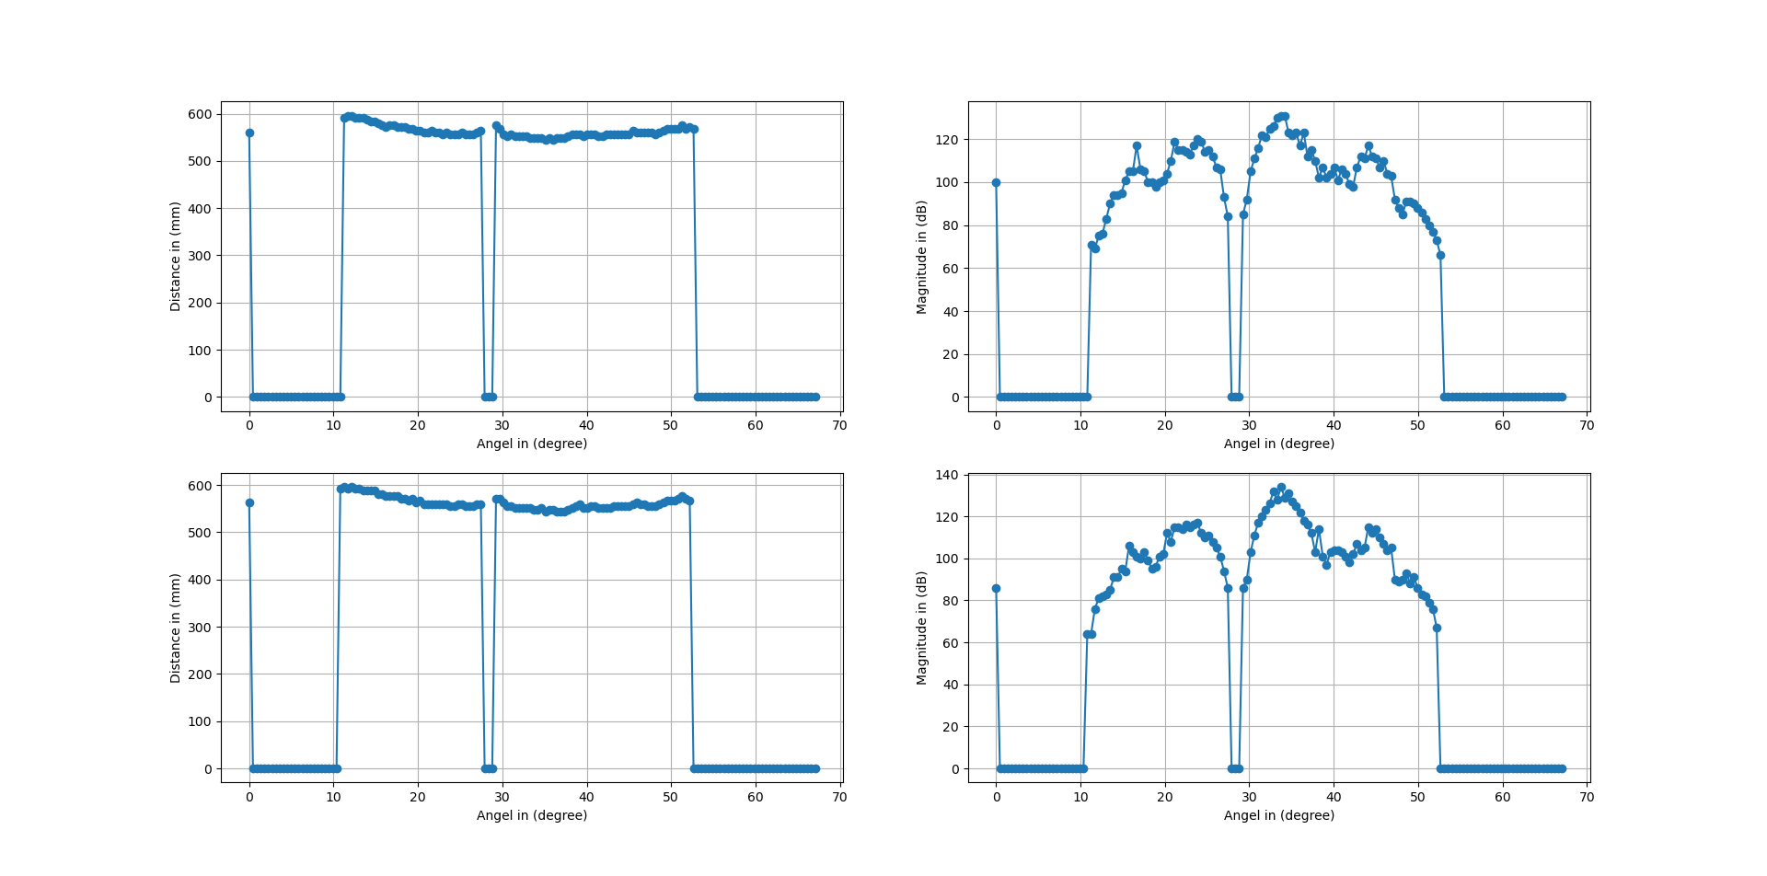

Row number # 1

[100, 0, 0, 0, 0, 0, 0, 0, 0, 0, 0, 0, 0, 0, 0, 0, 0, 0, 0, 0, 0, 0, 0, 0, 0, 71, 69, 75, 76, 83, 90, 94, 94, 95, 101, 105, 105, 117, 106, 105, 100, 100, 98, 100, 101, 104, 110, 119, 115, 115, 114, 113, 117, 120, 119, 114, 115, 112, 107, 106, 93, 84, 0, 0, 0, 85, 92, 105, 111, 116, 122, 121, 125, 126, 130, 131, 131, 123, 122, 123, 117, 123, 112, 115, 110, 102, 107, 102, 104, 107, 101, 106, 104, 99, 98, 107, 112, 111, 117, 112, 111, 107, 110, 104, 103, 92, 88, 85, 91, 91, 90, 88, 86, 83, 80, 77, 73, 66, 0, 0, 0, 0, 0, 0, 0, 0, 0, 0, 0, 0, 0, 0, 0, 0, 0, 0, 0, 0, 0, 0, 0, 0, 0, 0, 0, 0, 0, 0, 0, 0]

[560, 0, 0, 0, 0, 0, 0, 0, 0, 0, 0, 0, 0, 0, 0, 0, 0, 0, 0, 0, 0, 0, 0, 0, 0, 592, 596, 596, 592, 592, 592, 588, 584, 584, 580, 576, 572, 576, 576, 572, 572, 572, 568, 568, 564, 564, 560, 560, 564, 560, 560, 556, 560, 556, 556, 556, 560, 556, 556, 556, 560, 564, 0, 0, 0, 576, 568, 556, 552, 556, 552, 552, 552, 552, 548, 548, 548, 548, 544, 548, 544, 548, 548, 548, 552, 556, 556, 556, 552, 556, 556, 556, 552, 552, 556, 556, 556, 556, 556, 556, 556, 564, 560, 560, 560, 560, 560, 556, 560, 564, 568, 568, 568, 568, 576, 568, 572, 568, 0, 0, 0, 0, 0, 0, 0, 0, 0, 0, 0, 0, 0, 0, 0, 0, 0, 0, 0, 0, 0, 0, 0, 0, 0, 0, 0, 0, 0, 0, 0, 0]

Row number # 2

[86, 0, 0, 0, 0, 0, 0, 0, 0, 0, 0, 0, 0, 0, 0, 0, 0, 0, 0, 0, 0, 0, 0, 0, 64, 64, 76, 81, 82, 83, 85, 91, 91, 95, 94, 106, 103, 101, 100, 103, 99, 95, 96, 101, 102, 112, 108, 115, 115, 114, 116, 115, 116, 117, 112, 110, 111, 108, 105, 101, 94, 86, 0, 0, 0, 86, 90, 103, 111, 117, 120, 123, 126, 132, 128, 134, 129, 131, 127, 125, 122, 118, 116, 112, 103, 114, 101, 97, 103, 104, 104, 103, 101, 98, 102, 107, 104, 105, 115, 112, 114, 110, 107, 104, 105, 90, 89, 90, 93, 88, 91, 86, 83, 82, 79, 76, 67, 0, 0, 0, 0, 0, 0, 0, 0, 0, 0, 0, 0, 0, 0, 0, 0, 0, 0, 0, 0, 0, 0, 0, 0, 0, 0, 0, 0, 0, 0, 0, 0, 0]

[564, 0, 0, 0, 0, 0, 0, 0, 0, 0, 0, 0, 0, 0, 0, 0, 0, 0, 0, 0, 0, 0, 0, 0, 592, 596, 592, 596, 592, 592, 588, 588, 588, 588, 580, 580, 576, 576, 576, 576, 572, 572, 568, 572, 564, 568, 560, 560, 560, 560, 560, 560, 560, 556, 556, 560, 560, 556, 556, 556, 560, 560, 0, 0, 0, 572, 572, 564, 556, 556, 552, 552, 552, 552, 552, 548, 548, 552, 544, 548, 548, 544, 544, 544, 548, 552, 556, 560, 552, 552, 556, 556, 552, 552, 552, 552, 556, 556, 556, 556, 556, 560, 564, 560, 560, 556, 556, 556, 560, 564, 568, 568, 568, 572, 576, 572, 568, 0, 0, 0, 0, 0, 0, 0, 0, 0, 0, 0, 0, 0, 0, 0, 0, 0, 0, 0, 0, 0, 0, 0, 0, 0, 0, 0, 0, 0, 0, 0, 0, 0]

Guard number = 8

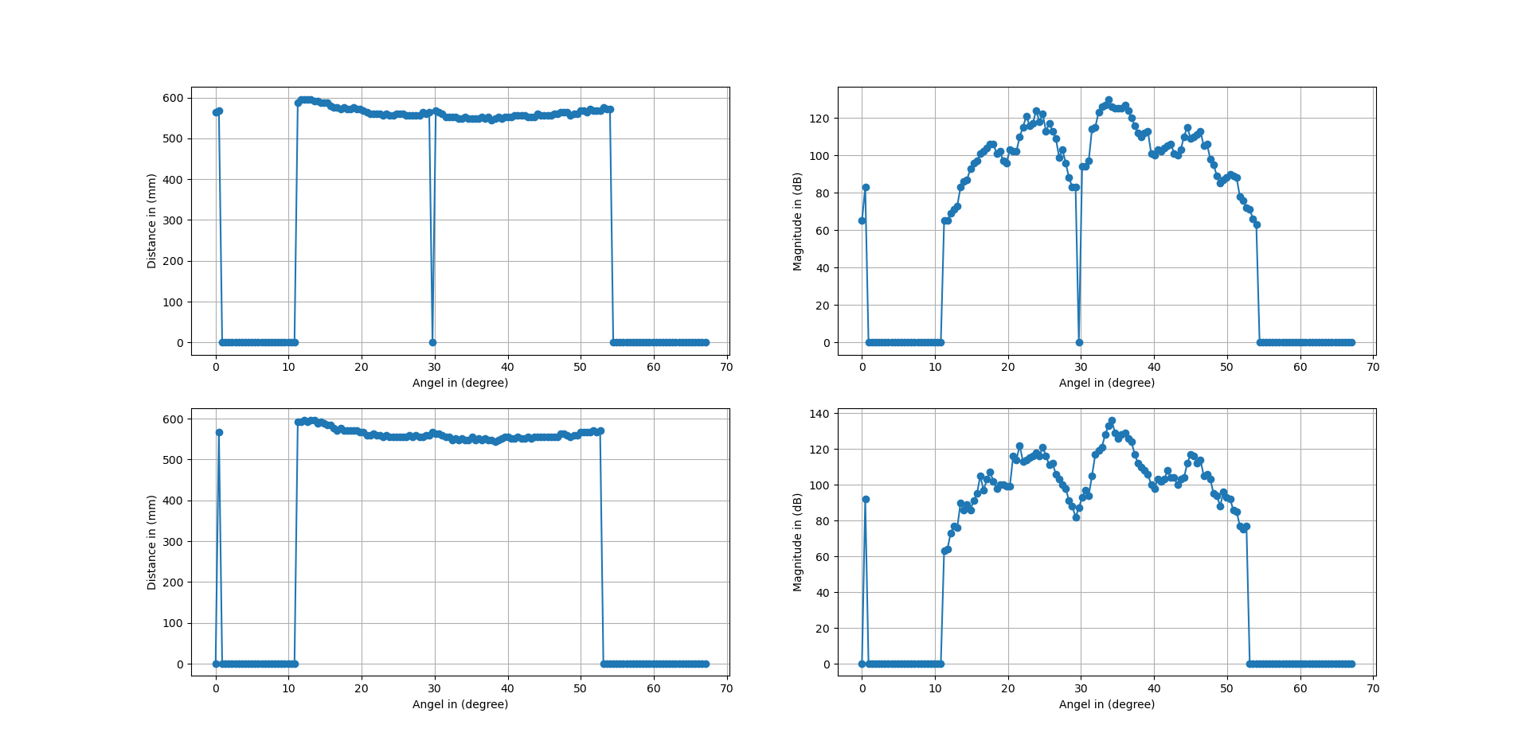

Row number # 1

[65, 83, 0, 0, 0, 0, 0, 0, 0, 0, 0, 0, 0, 0, 0, 0, 0, 0, 0, 0, 0, 0, 0, 0, 0, 65, 65, 69, 71, 73, 83, 86, 87, 93, 96, 97, 101, 102, 104, 106, 106, 101, 102, 97, 96, 103, 102, 102, 110, 115, 121, 116, 117, 124, 118, 122, 113, 117, 113, 109, 99, 103, 96, 88, 83, 83, 0, 94, 94, 97, 114, 115, 123, 126, 127, 130, 126, 125, 125, 125, 127, 124, 120, 116, 112, 110, 112, 113, 101, 100, 103, 102, 104, 105, 106, 101, 100, 103, 110, 115, 109, 110, 111, 113, 105, 106, 98, 95, 89, 85, 87, 88, 90, 89, 88, 78, 76, 72, 71, 66, 63, 0, 0, 0, 0, 0, 0, 0, 0, 0, 0, 0, 0, 0, 0, 0, 0, 0, 0, 0, 0, 0, 0, 0, 0, 0, 0, 0, 0, 0]

[564, 568, 0, 0, 0, 0, 0, 0, 0, 0, 0, 0, 0, 0, 0, 0, 0, 0, 0, 0, 0, 0, 0, 0, 0, 588, 596, 596, 596, 596, 592, 592, 588, 588, 588, 580, 576, 576, 572, 576, 572, 572, 576, 572, 572, 568, 564, 560, 560, 560, 560, 556, 560, 556, 556, 560, 560, 560, 556, 556, 556, 556, 556, 564, 560, 564, 0, 568, 564, 560, 552, 552, 552, 552, 548, 548, 552, 548, 548, 548, 548, 552, 548, 552, 544, 548, 552, 548, 552, 552, 552, 556, 556, 556, 556, 552, 552, 552, 560, 556, 556, 556, 556, 560, 560, 564, 564, 564, 556, 560, 560, 568, 568, 564, 572, 568, 568, 568, 576, 572, 572, 0, 0, 0, 0, 0, 0, 0, 0, 0, 0, 0, 0, 0, 0, 0, 0, 0, 0, 0, 0, 0, 0, 0, 0, 0, 0, 0, 0, 0]

Row number # 2

[0, 92, 0, 0, 0, 0, 0, 0, 0, 0, 0, 0, 0, 0, 0, 0, 0, 0, 0, 0, 0, 0, 0, 0, 0, 63, 64, 73, 77, 76, 90, 86, 89, 86, 91, 95, 105, 97, 103, 107, 102, 98, 100, 100, 99, 99, 116, 114, 122, 113, 114, 115, 116, 118, 116, 121, 116, 111, 112, 106, 103, 100, 98, 91, 88, 82, 87, 93, 97, 94, 105, 117, 119, 121, 128, 133, 136, 129, 126, 128, 129, 126, 124, 117, 112, 110, 108, 106, 100, 98, 103, 102, 103, 108, 104, 104, 100, 103, 104, 112, 117, 116, 112, 114, 105, 106, 103, 95, 94, 88, 96, 93, 92, 86, 85, 77, 75, 77, 0, 0, 0, 0, 0, 0, 0, 0, 0, 0, 0, 0, 0, 0, 0, 0, 0, 0, 0, 0, 0, 0, 0, 0, 0, 0, 0, 0, 0, 0, 0, 0]

[0, 568, 0, 0, 0, 0, 0, 0, 0, 0, 0, 0, 0, 0, 0, 0, 0, 0, 0, 0, 0, 0, 0, 0, 0, 592, 592, 596, 592, 596, 596, 588, 592, 588, 584, 584, 576, 572, 576, 572, 572, 572, 572, 572, 568, 568, 560, 560, 564, 560, 560, 556, 560, 556, 556, 556, 556, 556, 556, 560, 556, 560, 556, 556, 560, 560, 568, 564, 564, 560, 556, 556, 548, 552, 548, 552, 548, 548, 556, 548, 552, 548, 552, 548, 548, 544, 548, 552, 556, 556, 552, 552, 556, 552, 552, 556, 552, 556, 556, 556, 556, 556, 556, 556, 556, 564, 564, 560, 556, 560, 560, 568, 568, 568, 568, 572, 568, 572, 0, 0, 0, 0, 0, 0, 0, 0, 0, 0, 0, 0, 0, 0, 0, 0, 0, 0, 0, 0, 0, 0, 0, 0, 0, 0, 0, 0, 0, 0, 0, 0]

Environment:

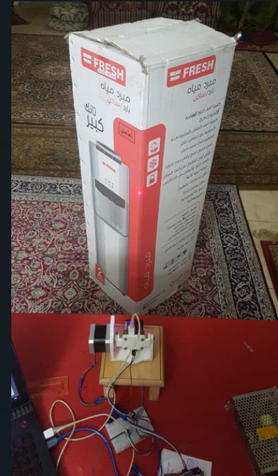

Distance between radar and object = 51 cm, Bin resolution = 4, Entering point = step number 32 14.4 degree, Exit point = step number 109 49.05 degree, Without CFAR, Total angel = 67.5 with step size = 1, Total number of steps = 150 step each step = 0.45 degree

Row number # 1

[-108, -103, -107, -101, -105, -106, -104, -103, -104, -101, -102, -100, -106, -107, -105, -103, -101, -105, -105, -96, -98, -97, -95, -95, -91, -82, -73, -63, -56, -51, -47, -44, -43, -43, -43, -44, -47, -45, -41, -36, -32, -30, -27, -25, -24, -25, -26, -30, -27, -22, -19, -7, -2, 0, 1, 2, 2, 1, 0, -2, -5, -9, -13, -17, -21, -27, -32, -34, -27, -26, -25, -26, -30, -35, -38, -47, -31, -25, -21, -17, -13, -12, -10, -10, -9, -8, -8, -9, -10, -12, -14, -16, -20, -30, -35, -42, -50, -53, -55, -56, -57, -48, -44, -41, -40, -41, -42, -44, -45, -49, -52, -56, -62, -67, -72, -79, -89, -94, -97, -94, -97, -96, -98, -95, -90, -92, -88, -91, -91, -94, -97, -106, -108, -106, -109, -109, -108, -109, -107, -112, -108, -107, -110, -106, -104, -105, -104, -103, -105, -100]

[576, 576, 568, 580, 600, 588, 592, 592, 600, 592, 592, 600, 616, 760, 684, 692, 688, 688, 584, 748, 748, 744, 640, 588, 660, 752, 764, 768, 764, 764, 768, 768, 768, 764, 764, 764, 752, 688, 684, 680, 672, 672, 668, 664, 664, 660, 664, 660, 584, 592, 592, 592, 588, 588, 584, 584, 584, 580, 576, 580, 580, 576, 576, 572, 576, 568, 564, 528, 532, 528, 532, 532, 532, 532, 528, 520, 604, 604, 600, 600, 604, 600, 608, 608, 612, 620, 624, 624, 632, 632, 636, 632, 636, 632, 632, 632, 704, 704, 712, 724, 724, 784, 780, 784, 784, 780, 784, 792, 796, 796, 796, 796, 796, 796, 796, 796, 796, 796, 788, 792, 796, 796, 796, 796, 796, 796, 796, 796, 796, 796, 792, 644, 704, 688, 644, 776, 768, 760, 688, 660, 680, 680, 596, 756, 768, 756, 580, 580, 756, 744]

Row number # 2

[-104, -77, -107, -106, -106, -100, -104, -104, -102, -104, -103, -103, -111, -109, -109, -105, -98, -104, -107, -104, -99, -98, -94, -92, -90, -85, -74, -64, -57, -52, -48, -44, -43, -43, -43, -44, -47, -45, -41, -36, -32, -30, -27, -25, -24, -25, -27, -30, -28, -23, -15, -8, -2, 0, 1, 2, 2, 1, 0, -2, -6, -9, -12, -16, -21, -26, -28, -34, -34, -27, -25, -26, -28, -36, -43, -47, -34, -25, -21, -17, -14, -12, -11, -10, -9, -9, -8, -9, -10, -12, -15, -19, -23, -29, -36, -43, -50, -53, -55, -56, -54, -47, -44, -41, -40, -41, -42, -44, -46, -48, -51, -57, -62, -65, -71, -80, -88, -95, -98, -96, -97, -98, -99, -96, -92, -89, -90, -89, -90, -94, -96, -105, -106, -105, -108, -107, -104, -109, -112, -109, -106, -104, -107, -106, -109, -106, -105, -104, -104, -99]

[608, 592, 576, 584, 588, 588, 600, 596, 600, 608, 588, 600, 696, 796, 688, 712, 684, 684, 692, 740, 748, 644, 644, 652, 792, 756, 764, 768, 764, 764, 764, 772, 768, 764, 764, 764, 756, 684, 680, 676, 672, 672, 668, 664, 664, 660, 660, 664, 584, 588, 592, 588, 592, 588, 588, 584, 584, 584, 576, 576, 576, 576, 580, 576, 580, 576, 572, 564, 528, 532, 532, 536, 536, 528, 528, 608, 604, 604, 604, 600, 600, 600, 600, 604, 612, 612, 624, 624, 632, 636, 632, 636, 636, 632, 632, 628, 704, 704, 712, 728, 784, 784, 784, 784, 784, 784, 788, 788, 796, 796, 796, 796, 796, 796, 796, 796, 796, 796, 792, 796, 796, 796, 796, 796, 796, 792, 796, 796, 796, 796, 792, 780, 640, 676, 700, 636, 772, 672, 428, 588, 680, 756, 680, 764, 680, 584, 752, 596, 612, 604]

########################################################################################

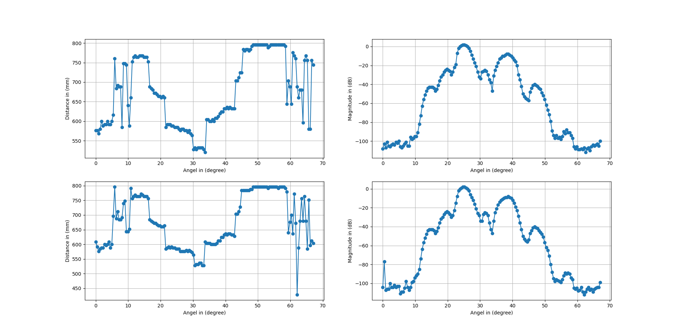

Distance between radar and object = 51 cm, Bin resolution = 4, Entering point = step number 27 12.15 degree, Exit point = step number 104 46.8 degree, With CFAR and calibration, Total angel = 67.5 with step size = 1, Total number of steps = 150 step each step = 0.47 degree

Guard number = 5

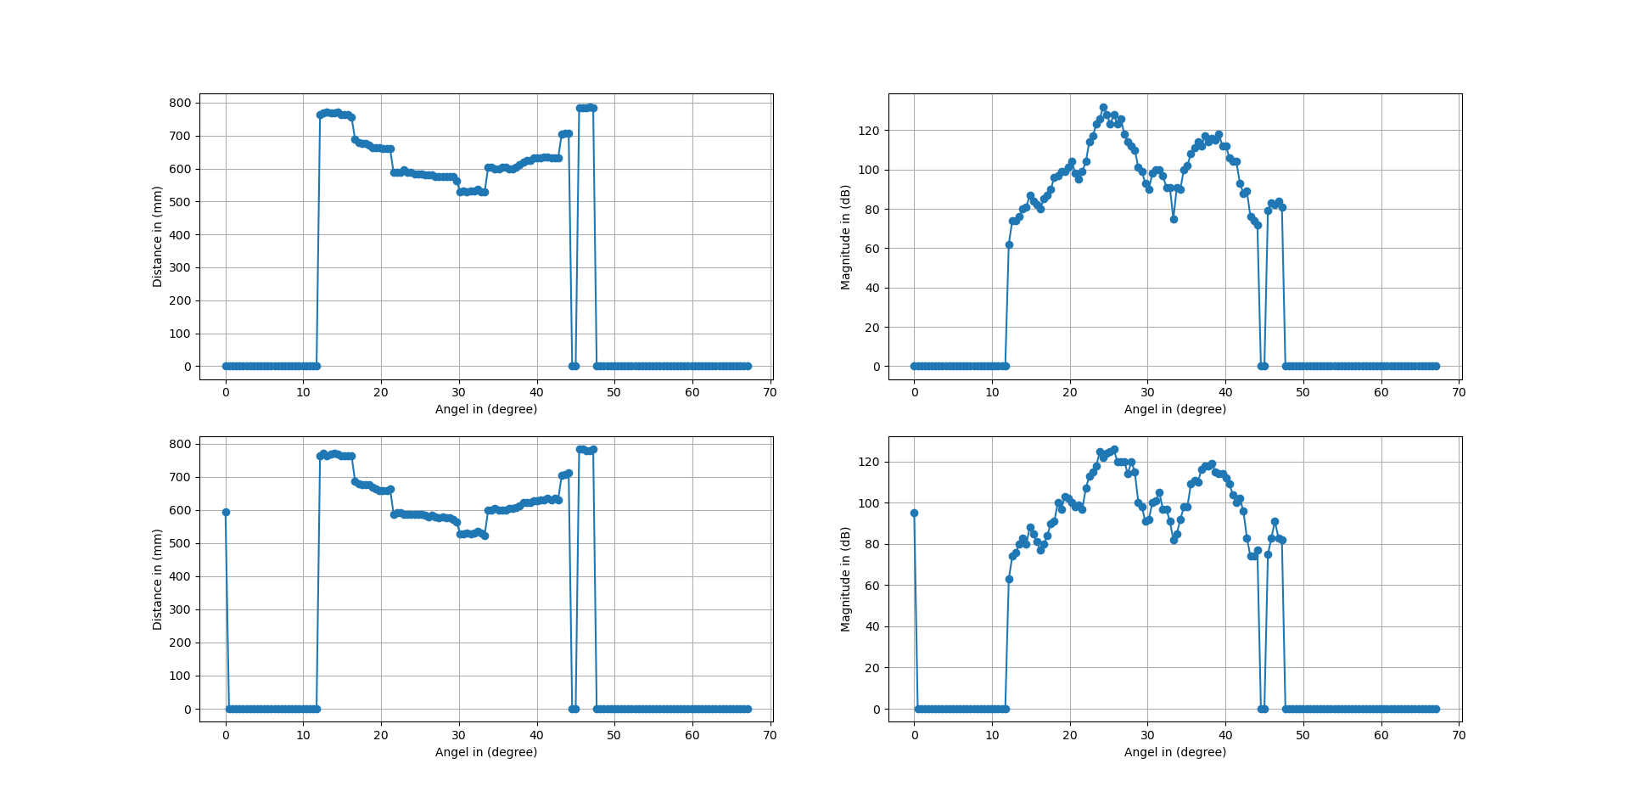 Row number # 1

[0, 0, 0, 0, 0, 0, 0, 0, 0, 0, 0, 0, 0, 0, 0, 0, 0, 0, 0, 0, 0, 0, 0, 0, 0, 0, 0, 62, 74, 74, 76, 80, 81, 87, 84, 82, 80, 85, 87, 90, 96, 97, 99, 99, 101, 104, 98, 95, 99, 104, 114, 117, 123, 126, 132, 128, 123, 128, 123, 126, 118, 114, 112, 110, 101, 99, 93, 90, 98, 100, 100, 97, 91, 91, 75, 91, 90, 100, 102, 108, 111, 114, 112, 117, 114, 116, 115, 118, 112, 112, 106, 104, 104, 93, 88, 89, 76, 74, 72, 0, 0, 79, 83, 82, 84, 81, 0, 0, 0, 0, 0, 0, 0, 0, 0, 0, 0, 0, 0, 0, 0, 0, 0, 0, 0, 0, 0, 0, 0, 0, 0, 0, 0, 0, 0, 0, 0, 0, 0, 0, 0, 0, 0, 0, 0, 0, 0, 0, 0, 0]

[0, 0, 0, 0, 0, 0, 0, 0, 0, 0, 0, 0, 0, 0, 0, 0, 0, 0, 0, 0, 0, 0, 0, 0, 0, 0, 0, 764, 768, 772, 768, 768, 772, 764, 764, 764, 756, 688, 680, 676, 676, 672, 664, 664, 664, 660, 660, 660, 588, 588, 588, 596, 588, 588, 584, 584, 584, 580, 580, 580, 576, 576, 576, 576, 576, 576, 564, 528, 532, 528, 532, 532, 536, 528, 528, 604, 604, 600, 600, 604, 604, 600, 600, 604, 612, 620, 624, 624, 632, 632, 632, 636, 636, 632, 632, 632, 704, 708, 708, 0, 0, 784, 784, 784, 788, 784, 0, 0, 0, 0, 0, 0, 0, 0, 0, 0, 0, 0, 0, 0, 0, 0, 0, 0, 0, 0, 0, 0, 0, 0, 0, 0, 0, 0, 0, 0, 0, 0, 0, 0, 0, 0, 0, 0, 0, 0, 0, 0, 0, 0]

Row number # 2

[95, 0, 0, 0, 0, 0, 0, 0, 0, 0, 0, 0, 0, 0, 0, 0, 0, 0, 0, 0, 0, 0, 0, 0, 0, 0, 0, 63, 74, 76, 80, 83, 80, 88, 85, 81, 77, 80, 84, 90, 91, 100, 97, 103, 102, 100, 98, 99, 97, 107, 113, 115, 118, 125, 122, 124, 125, 126, 120, 120, 120, 114, 120, 115, 100, 98, 91, 92, 100, 101, 105, 97, 97, 91, 82, 85, 92, 98, 98, 109, 111, 110, 116, 118, 118, 119, 115, 114, 114, 112, 109, 104, 100, 102, 96, 83, 74, 74, 77, 0, 0, 75, 83, 91, 83, 82, 0, 0, 0, 0, 0, 0, 0, 0, 0, 0, 0, 0, 0, 0, 0, 0, 0, 0, 0, 0, 0, 0, 0, 0, 0, 0, 0, 0, 0, 0, 0, 0, 0, 0, 0, 0, 0, 0, 0, 0, 0, 0, 0, 0]

[596, 0, 0, 0, 0, 0, 0, 0, 0, 0, 0, 0, 0, 0, 0, 0, 0, 0, 0, 0, 0, 0, 0, 0, 0, 0, 0, 764, 772, 764, 768, 772, 768, 764, 764, 764, 764, 688, 680, 676, 676, 676, 668, 664, 660, 660, 660, 664, 588, 592, 592, 588, 588, 588, 588, 588, 588, 584, 580, 584, 580, 576, 580, 576, 576, 572, 564, 528, 528, 532, 528, 532, 536, 532, 524, 600, 600, 604, 600, 600, 600, 604, 604, 608, 612, 624, 624, 624, 628, 628, 632, 632, 636, 632, 636, 632, 704, 708, 712, 0, 0, 784, 784, 780, 780, 784, 0, 0, 0, 0, 0, 0, 0, 0, 0, 0, 0, 0, 0, 0, 0, 0, 0, 0, 0, 0, 0, 0, 0, 0, 0, 0, 0, 0, 0, 0, 0, 0, 0, 0, 0, 0, 0, 0, 0, 0, 0, 0, 0, 0]